Find the Nyquist Plot for the following bode plot. The open loop has one poles in RHP, is the closed loop stable?
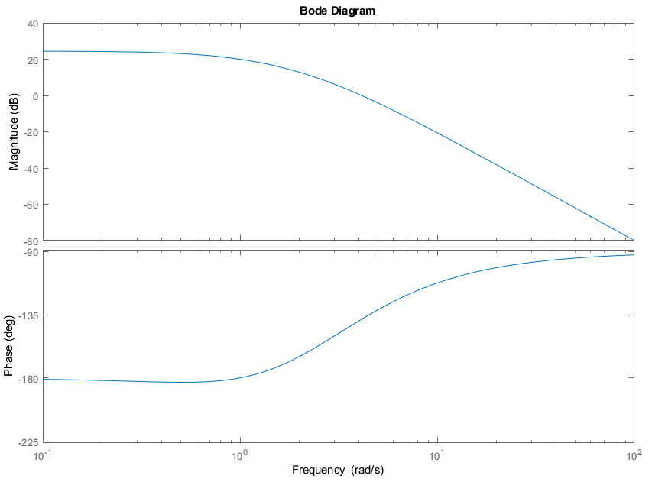
Freq (rad/s) | Mag (dB) | Mag | Phase= θ | X=Mag*cos(θ) | Y= Mag*sin(θ)
0.01 | 25.4 | 18.62 | -180 | -18.62 | 0
0.1 | 25 | 17.78 | -181 | -17.78 | 0.31
0.3 | 24 | 15.85 | -182 | -15.84 | 0.553
0.5 | 23 | 14.13 | -183 | -14.11 | 0.74
0.8 | 21 | 11.22 | -182 | -11.21 | 0.392
1 | 20 | 10 | -180 | -10 | 0
1.3 | 18 | 7.94 | -176 | -7.92 | -0.554
2 | 13 | 4.47 | -165 | -4.32 | -1.157
4 | 0.68 | 1.08 | -140 | -0.83 | -0.694
10 | -20.6 | 0.09 | -112 | -0.03 | -0.083
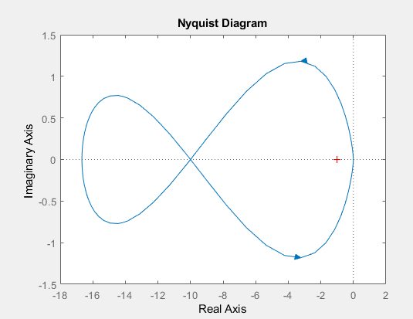

Find the Nyquist Plot for the following bode plot. The open loop is stable, is the closed loop stable?
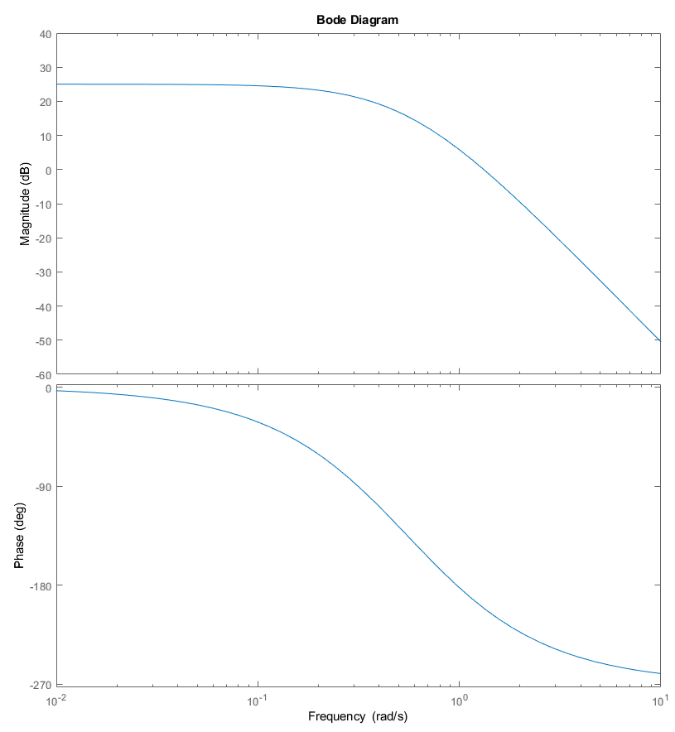
Freq (rad/s) | Mag (dB) | Mag | Phase | X = Re{s} | Y = Im{s}
0.01 | 25 | 17.78 | 0 | 17.78 | 0
0.1 | 24.5 | 16.79 | -32 | 14.24 | -8.897
0.3 | 21 | 11.22 | -86 | 0.78 | -11.19
0.7 | 12 | 3.98 | -156 | -3.64 | -1.619
1 | 5.8 | 1.95 | -182 | -1.95 | 0.068
1.26 | 1 | 1.12 | -198 | -1.07 | 0.346
5 | -32 | 0.03 | -251 | -0.01 | 0.028
